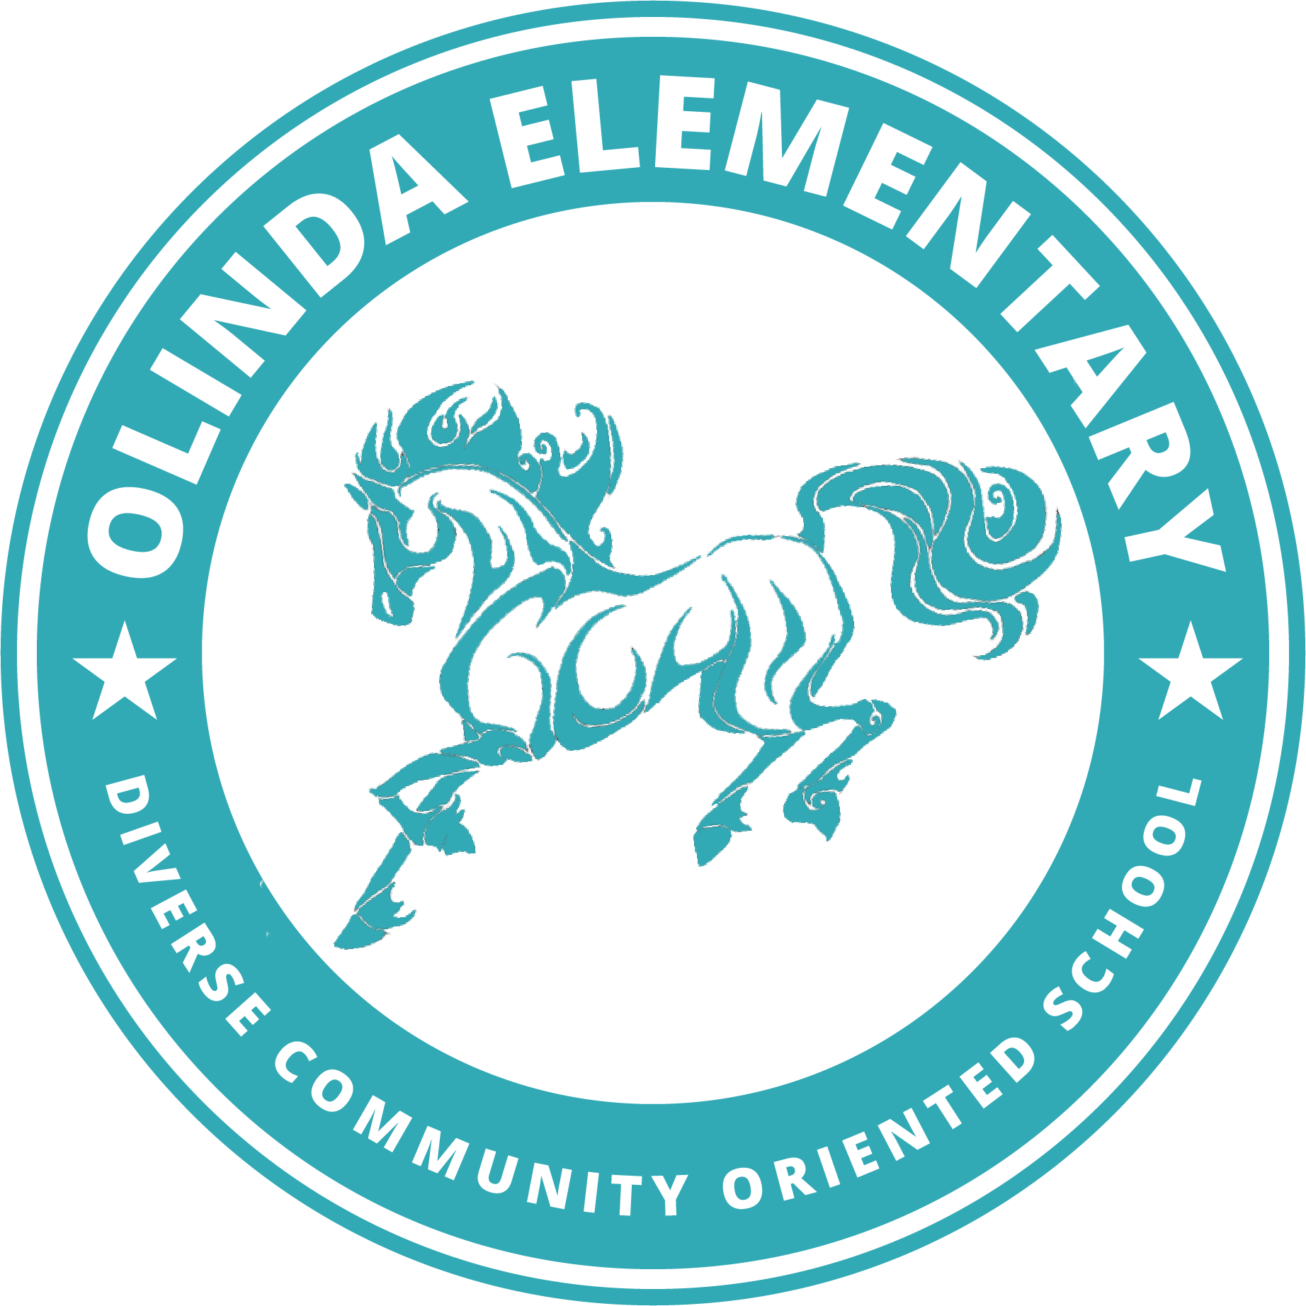

August 2021

Welcome to 4th Grade! School starts on August 16th, and I am looking forward to meeting you! We will be learning together in **Room 17**.

The items and precautions below will help us stay healthy, and keep our classroom safe until the COVID virus is contained and controlled.

Everyday, you will need:

* **Your school assigned *fully charged* tablet AND the power chord/charger.**
* **At least two, but maybe 3 masks that are in a clean zip-closing plastic bag in the backpack - in case the one you come to school in gets dirty.**
* **Two ziploc sandwich bags - one for your clean masks and one for the used ones.**
* **A water bottle (reuseable) filled ONLY with water. It should be recloseable when you are not drinking from it. A cover will add an extra layer of protection.**

Your used masks should be ***washed daily*** if you plan to use the same ones each day. Do not come to school in a dirty or previously worn, and unwashed mask.

(So, if you cannot wash them every day, have 5-6 masks on hand so you always have 2 - 3 clean masks ready in your backpack). Masks may have many sorts of decorations, or none at all.

Masks should not have logos of alcohol, profanity, or other items outlined as being inappropriate for school

in the [Student Handbook](https://www.wccusd.net/domain/2439).

* A washable [small](https://www.staples.com/Staples-Pencil-Box-Translucent-Clear/product_472593) [pencil box or](https://www.target.com/p/sterilite-pencil-box/-/A-83757535?preselect=14790827#lnk=sametab) [an expandable one](https://www.target.com/p/expandable-flexi-storage-pencil-box-it-s-academic/-/A-82865752?preselect=81578827#lnk=sametab) (here are 3 suggestions)
* 2 sharpened #2 wood pencils
* An eraser
* An [closed (Office Depot/ Office Max) pencil sharpener](https://www.officedepot.com/catalog/search.do?Ntt=two+hole+sharpeners) ([Bostitch](https://www.staples.com/Bostitch-Twist-N-Sharp-Pencil-Sharpener-Manual-Assorted-PS1-ADJ/product_1641097), [Steadler](https://www.staples.com/Staedtler-2-Hole-Pencil-Sharpener/product_385099?back=true)) a personal sharpener with a cover so the pencil shavings do not fall out).
* A [college ruled one subject notebook](https://www.staples.com/Staples-1-Subject-Notebook-College-Ruled-8-x-10-1-2-Assorted-Colors-27498M/product_1485056) and 2 college ruled composition books: [1 black,](https://www.staples.com/Staples-Composition-Notebook-College-Ruled-Black-9-3-4-x-7-1-2-Each-40451M-CC/product_919350) and [1 green](https://www.staples.com/Staples-Composition-Notebook-College-Ruled-9-3-4-x-7-1-2-Green/product_962512).
* [A 12” x 12” plastic document or scrapbook case](https://www.michaels.com/12in-x-12in-clear-scrapbook-case-by-simply-tidy/10575615.html) (or similar) for your work and important papers.
* [One container of Clorox (or Lysol) wipes to clean your desk with](https://www.target.com/p/clorox-compostable-wipes-lemon-75ct/-/A-78314373)
* [A box of tissues](https://www.target.com/p/facial-tissues-up-up/-/A-79834432?preselect=53524230#lnk=sametab) (it can be any brand - it will be for your use only)

If you want, you might get some:

* Flair or Ink Joy color pens (for writing)
* Crayola Markers - [regular](https://www.staples.com/crayola-markers-assorted-colors-bonus-pack-12-box-58-7750/product_24387000) or [fine point](https://www.staples.com/Crayola-Classic-Markers-Fine-Line-10-Box/product_381809)

*These items and the links are examples of what you will need - if you find the same item elsewhere - please don’t feel that you must only buy at Target, or Staples, or Office Max! If you do buy at Target, get the app on your phone and you can have your things brought to you in your car - contact-free. Staples and Office Max may have free shipping to your home.*

***I will provide each of you with your own personal***

* ***Set of 12 colored pencils and a 24-color box of crayons, and glue stick (saved in your pencil box)***
* ***Dry Erase marker, eraser, white board.***
* ***A plastic “envelope” to keep papers that are “in-progress”***
* ***Graph paper math workbooks, rulers, and protractors***
* ***Science and Art materials and special papers when we use them.***

Here is our learning schedule starting Monday, August 16, 2021:

**Intermediate Instructional Schedule**

**Grades 4 - 6**

| 9:00 a.m to 9:30 a.m.: | Instruction |
| --- | --- |
| 9:30 a.m. - 10:15 a.m | Instruction |
| 10:15 a.m. to 10:25 a.m.: | Recess |
| 10:25 a.m. to 12:00 p.m.: | Instruction |
| 12:00 p.m. to 12:20 p.m.: | Lunch |
| 12:20 p.m. to 12:40 p.m.: | Lunch Recess |
| 12:40 p.m. to 1:40 p.m.: | Instruction |
| 1:40 p.m. to 1:50 p.m.: | Recess |
| 1:50 p.m. to 3:15 p.m.: | Instruction |

3:15 p.m.: Dismissal (2:15 p.m.on Mimimum Days) FRIDAYS are Minimum Days!

If you have any questions, [check the website](https://www.wccusd.net/olinda) where you will find the FAQ, links to the student handbook, and other information! To reach me, you can email me at [mpannu@wccusd.net](mailto:mpannu@wccusd.net), or (after August 12th), on Class Dojo.

See you soon, Mrs. Pannu

